Task 4
- Register a free domain name https://www.infinityfree.com/
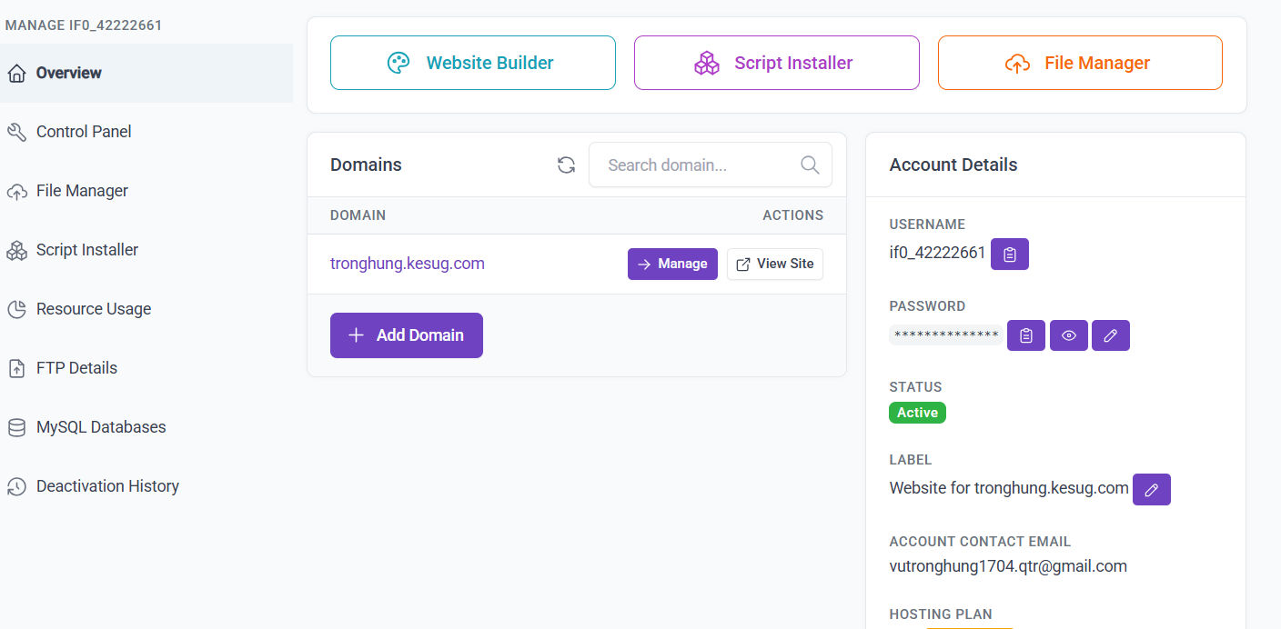
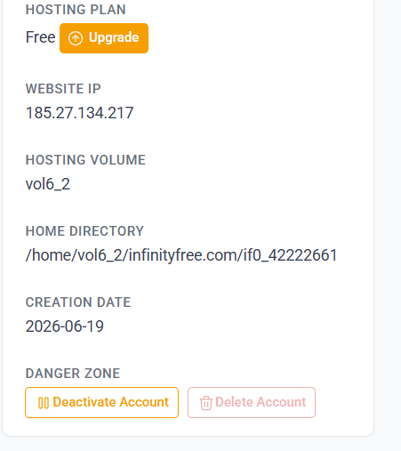
- Generate the key pair (using ECC) and certificate request
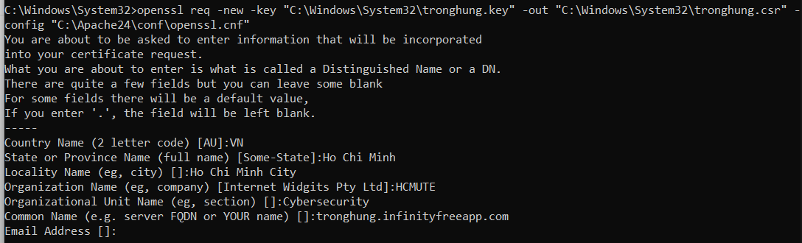

- Submit to Zerossl to sign the certificate
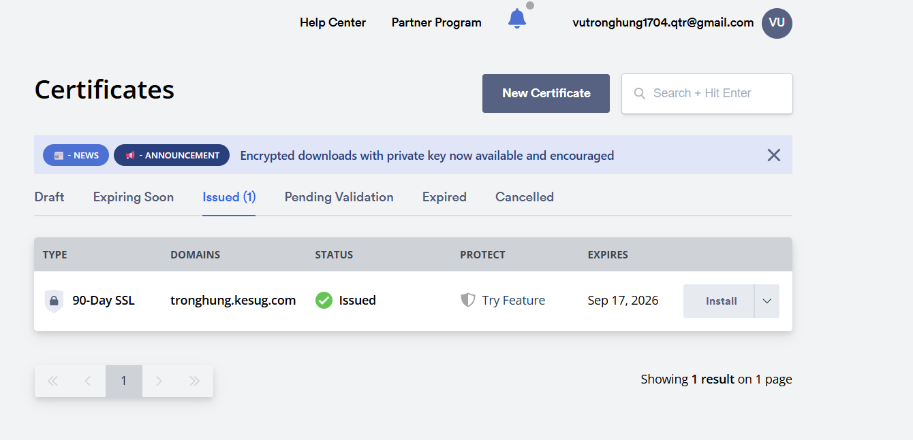
- Check certificate and CA chains

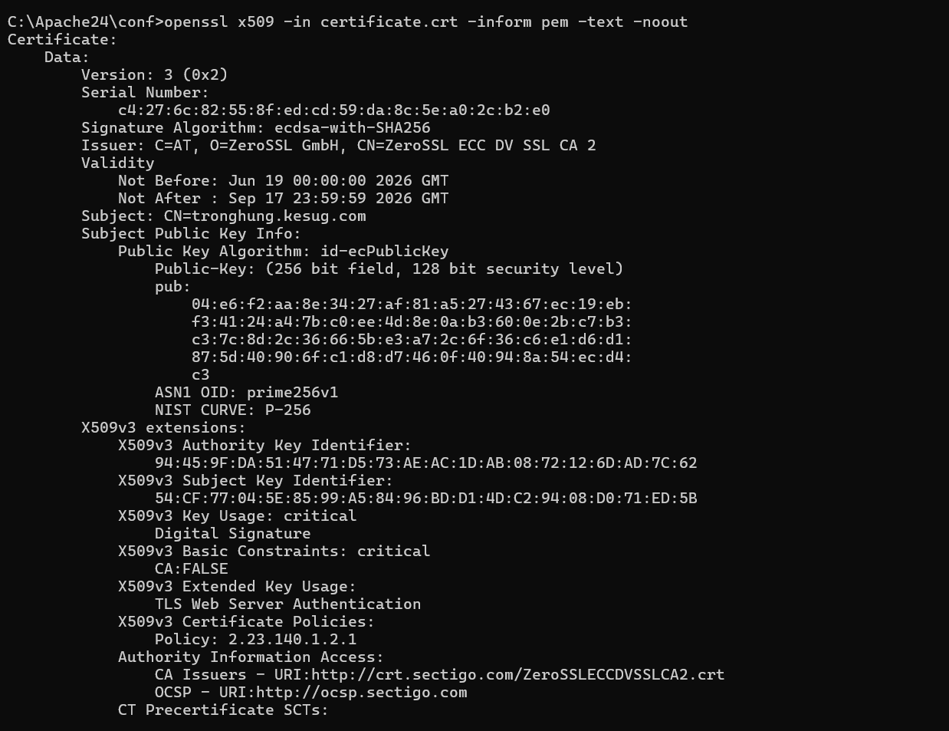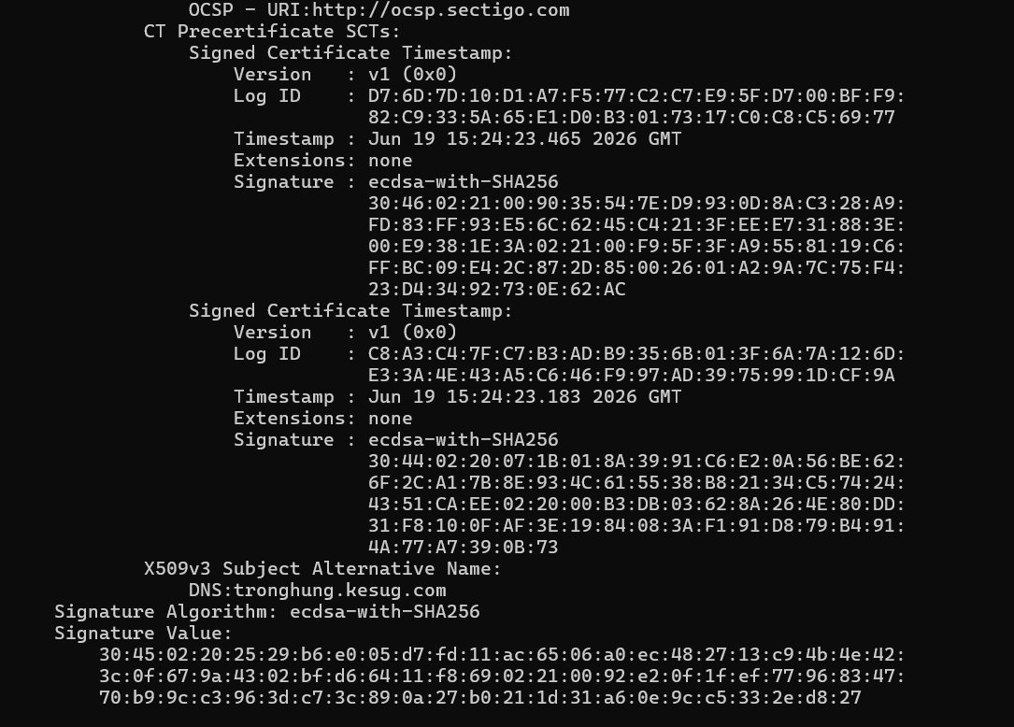
CA(ZeroSSL): Download certificate of ZeroSSL and check
http://crt.sectigo.com/ZeroSSLECCDVSSLCA2.crt
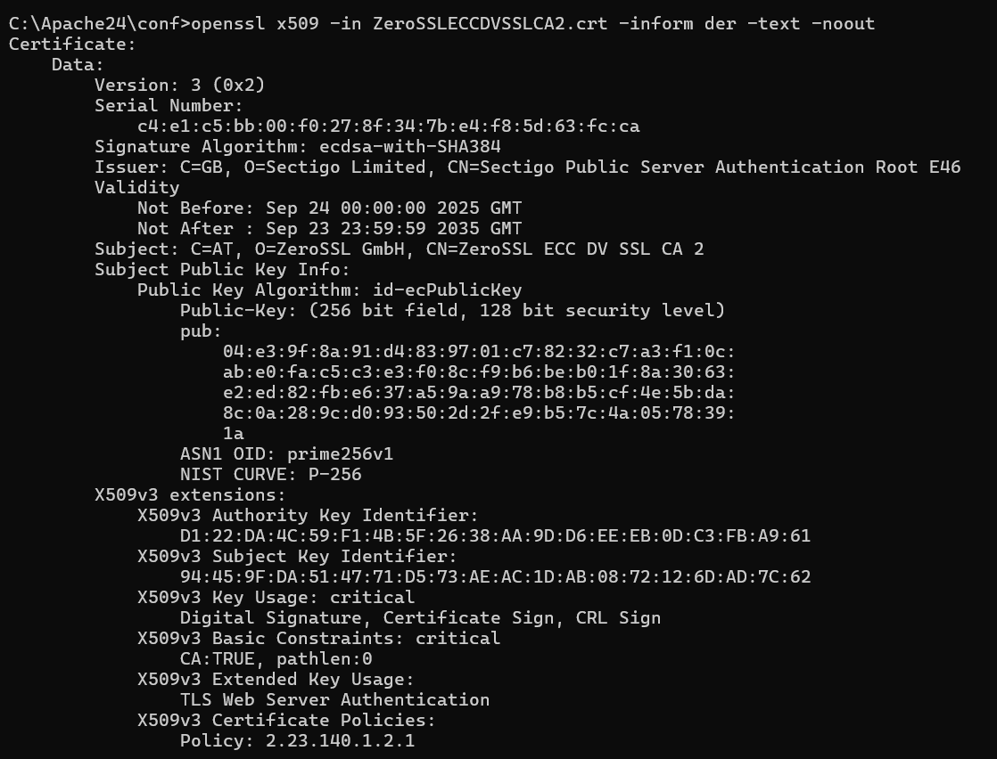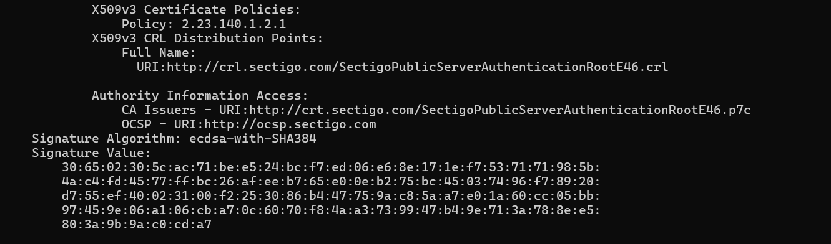

openssl pkcs7 -inform DER -in SectigoPublicServerAuthenticationRootE46.p7c -print_certs -text -noout
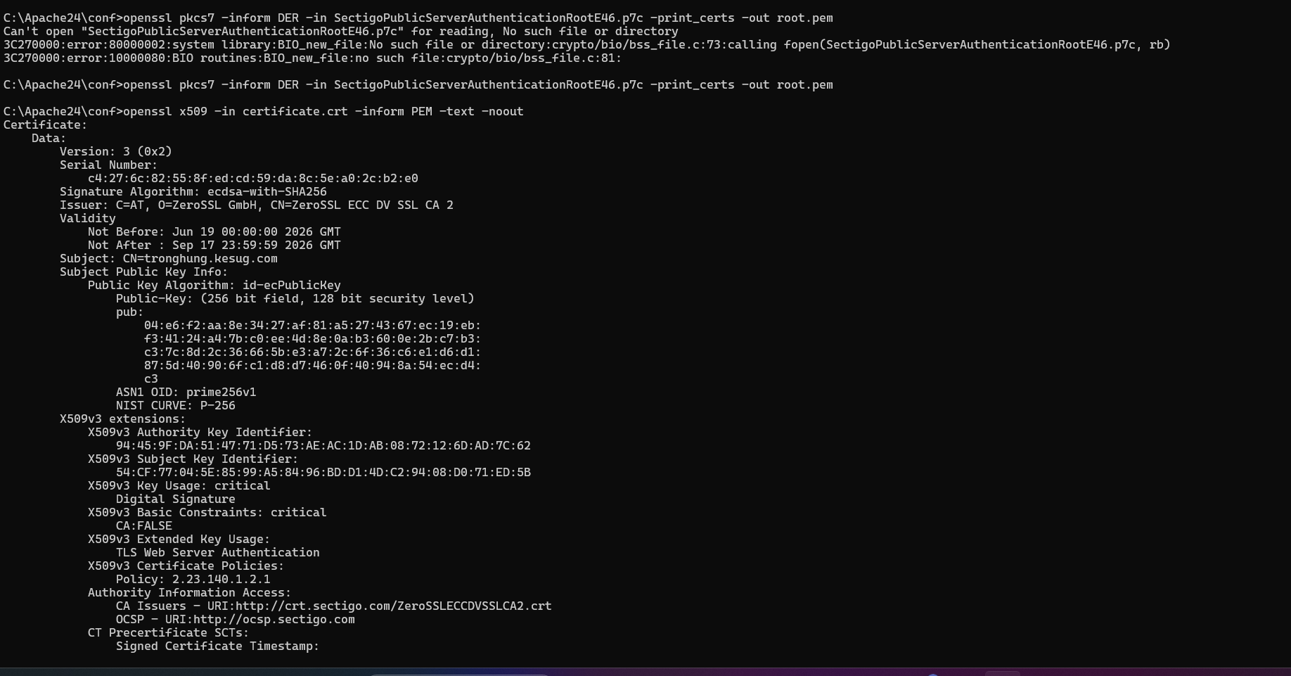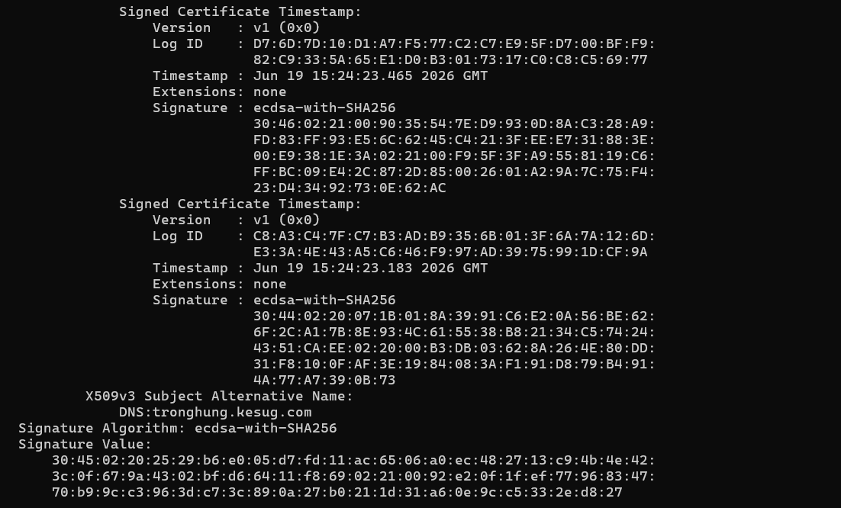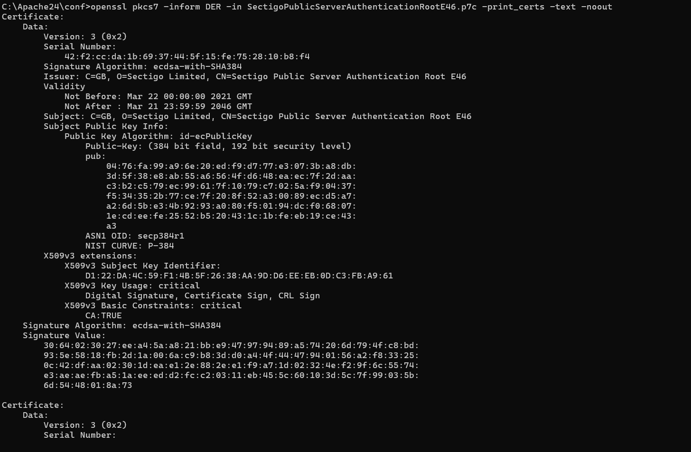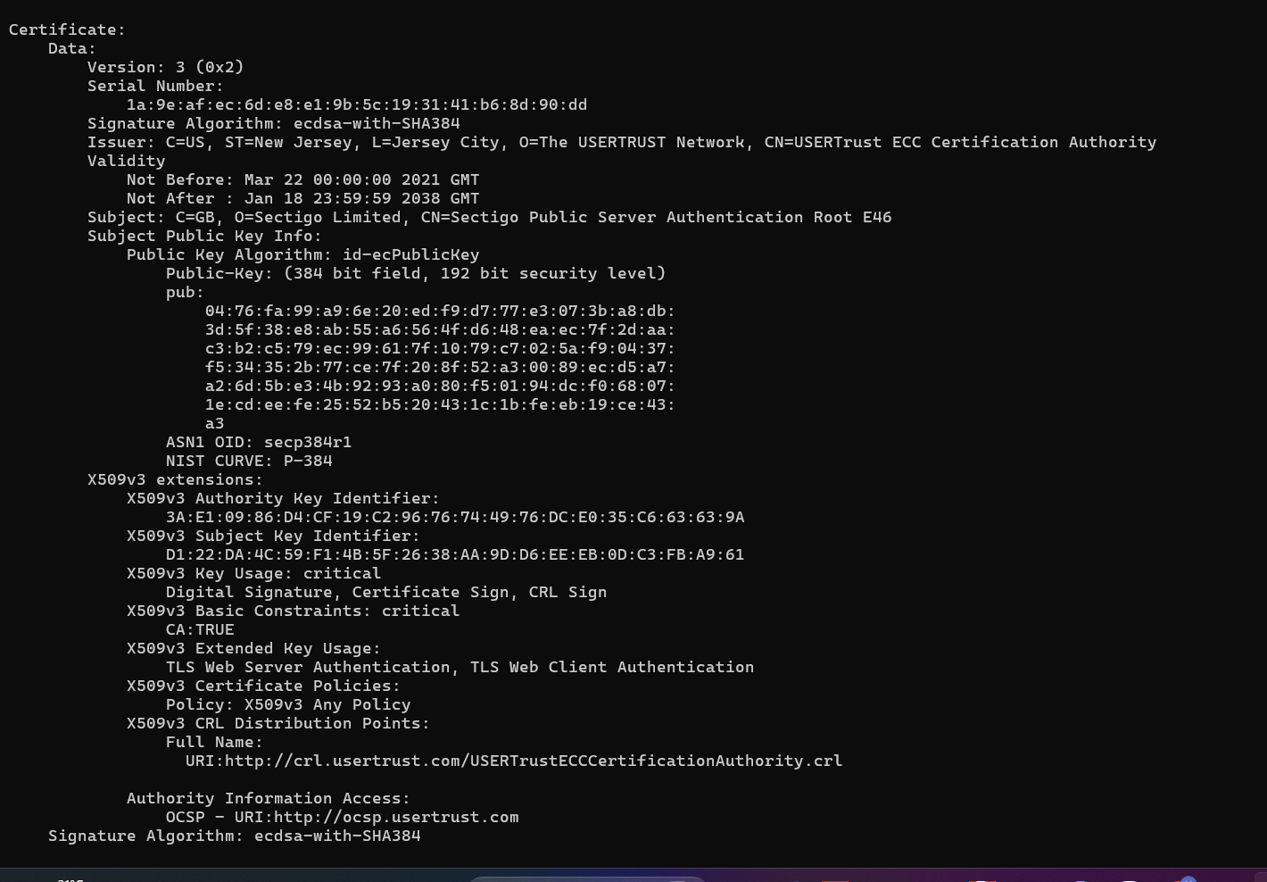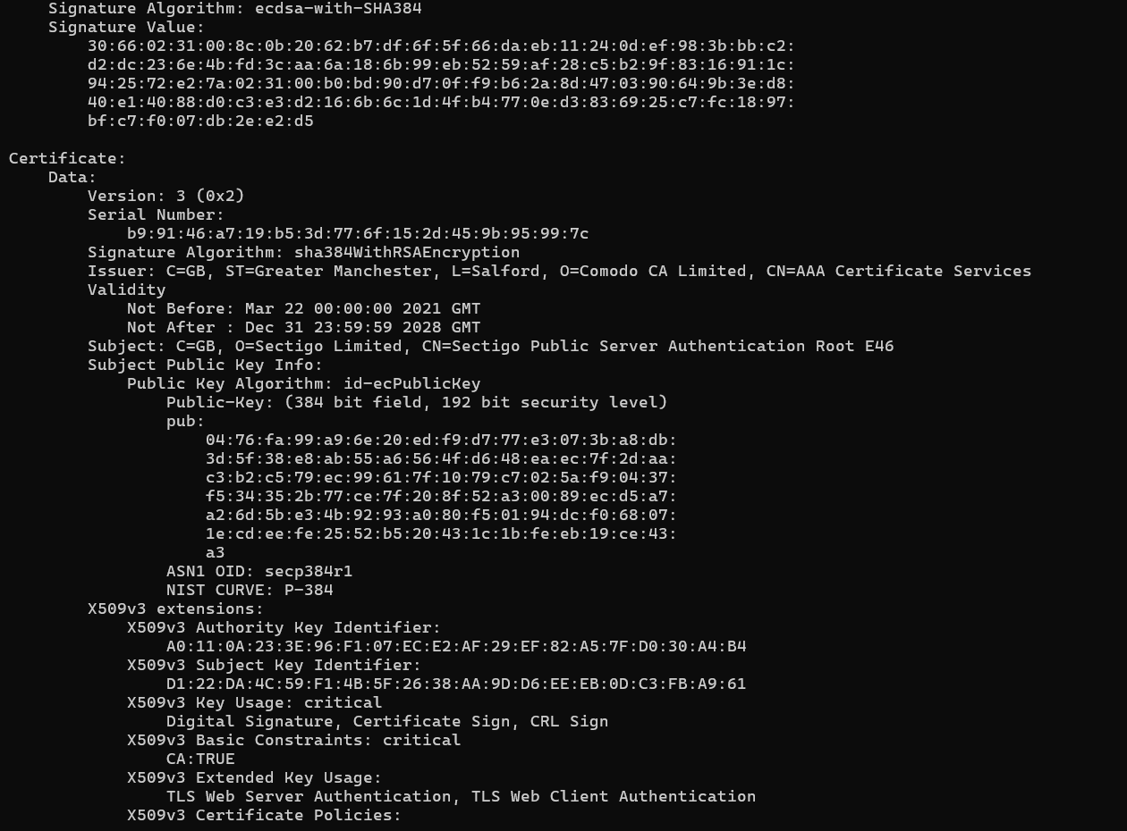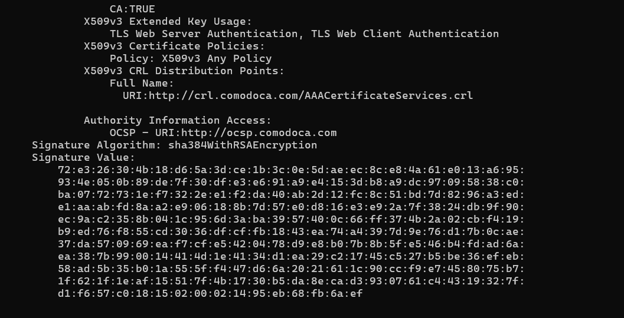
CA: AAA Certificate Services
AAACertificateServices.crt
